Available online at [www.sciencedirect.com](http://www.sciencedirect.com/)



AASRI Procedia 3 (2012) 694 – 699

2012 AASRI Conference on Modeling, Identification and Control

Influence of Cutting Interactions on Cutting Force of a Pick

Yong Sun*, X. S. Li

*CSIRO Earth Science and Resource Engineering, PO Box 883, Kenmore QLD 4069 Australia*

**Abstract**

Various mechanical excavators have been used for rock cutting. The cutting drum of an excavation machine normally consists of a large number of cutting picks. Accurate calculation of cutting force on individual picks is important to machine design and control. In rock cutting, cuts between picks can interact with each other. If a cutting force model has not considered the cutting interactions properly, the forces predicted by this model could significantly overestimate the “actual” force. On the other hand, many empirical cutting force models are developed based on laboratory test results using small Depth Of Cut (DOC) without significant cutting interactions. How to correctly applying these models to predict cutting force with large DOC is a challenge. This paper presents an approach for quantitatively analyzing the influences of cutting interactions on cutting force of a pick. The research results can help optimally select excavation machines and/or cutterhead motors, and optimize pick and drum design.

© 2012 The Authors. Published by Elsevier B.V. Open access under [CC BY-NC-ND license.](http://creativecommons.org/licenses/by-nc-nd/3.0/)

© 2012 Published by Elsevier B.V. Selection and/or peer review [under responsi](http://creativecommons.org/licenses/by-nc-nd/3.0/)bility of American Applied Science Research Institute

Selection and/or peer review under responsibility of American Applied Science Research Institute

*Keywords:* Mining engineering; Cutting force; Continuous mining; Drum design; Cutting picks; Cutting interactions

# Introduction

In mechanized continuous mining, selection of most appropriate machines and operational parameters heavily depends on the estimation of drum reactive torque and forces that are directly related to the forces acting on the individual picks of the drum. In addition, optimizing pick design also needs to have a good understanding of the forces acting on picks. Therefore, it is important to accurately predict the forces acting on a pick during mining production.

* Corresponding author. Tel.: +61 7 33274194; fax: +61 7 33274666.

*E-mail address:* [yong.sun@csiro.au.](mailto:yong.sun@csiro.au)

2212-6716 © 2012 The Authors. Published by Elsevier B.V. Open access under [CC BY-NC-ND license.](http://creativecommons.org/licenses/by-nc-nd/3.0/)

Selection and/or peer review under responsibility of American Applied Science Research Institute doi:10.1016/j.aasri.2012.11.110

In rock cutting, a pick is subject to three orthogonal forces, namely cutting force (also called drag force), normal force and sideway force (also called lateral force) [1]. This paper focuses on the cutting force as it is a major concern of existing literature. Researchers focus on the cutting force because it is the major force to form and remove chips from rock. It directly affects specific energy [2]. A lot of research effort has been made to calculate (predict) the cutting force of a pick [3-8]. Various cutting force models including theoretical, empirical, semi-empirical and numerical models have been developed. Although these models have various forms, consider different factors and developed based on different pick types (e.g., radial and point-attack), Depth of Cut (DOC) is always a major variable. For example, both Evans [3] and Goktan [4] indicated that cutting force is proportional to the square of DOC, but Yilmaz et al [5] revealed that the cutting force had a linear relationship with DOC while Liu et al [7] demonstrated that the cutting force had an exponential relationship with DOC based on their laboratory experiments.

Significant research effort has also been made to calculate DOC. Hurt et al [9] presented an approximate formula and a more exact equation in 1982. In 1996, Liu and Roxborough [10] further developed an accurate solution for the calculation of the DOC of a pick in a cutting cycle. However, these DOC calculation models are derived based on the picks which cut the same line. The cutting forces calculated using the existing force prediction models and DOC models are often far away from the observations in the mining production. The allowable linear advance speed (also called tram speed) of a drum based on the predicted cutting force is often much lower than the actual the linear advance speed in the production. In other words, if the mining machine is operated based on the predicted force, its productivity would be much lower than its actual capability. In fact, a drum used in mining production is normally composed of a number of cutting picks which cut a large area with multiple cutting lines. In this case, under certain conditions, the cuts between picks can have interactions as reported by Sun, et al in 2012 [11]. Their research showed that the cutting interactions between picks will reduce the “actual” DOC of the picks. Nevertheless, a quantitative analysis of the influence of cutting interactions on the cutting force of a pick is yet to be conducted. This paper attempts to address this issue. The research results can assist in understanding the influence of cutting interactions on the ‘actual’ DOC of picks so as to help the selection of excavation machines and/or cutterhead motors, optimize drum design and maximize mining productivity.

# Cutting interactions

As an example, Fig.1 shows a breakout pattern without cutting interaction (a) and a breakout pattern with cutting interaction (b).

In Fig. 1,  is the DOC of a pick in the breakout pattern plane which is the plane including the axis of the drum and parallel to the drum advance direction [11].  is breakout angle of cutting chips. , ,  and  are respectively the line spacing between Picks 1 and 2, the line spacing between Picks 2 and 3, the line spacing between Picks 3 and 4, as well as the line spacing between Picks 4 and 5.  is the advance distance of Pick 3 over Pick 5 in one revolution.  is the advance displacement per revolution of the drum. It is given by

*(1)*

where  is the linear advance speed of the drum and  is its rotational speed.

Drum advance direction



First cut

Second cut

Cut by Pick Cut by Pick Cut by Pick Cut by Pick Cut by Pick

1 2 3 4 5

Pick locations along drum axial direction

Drum advance direction

(a)

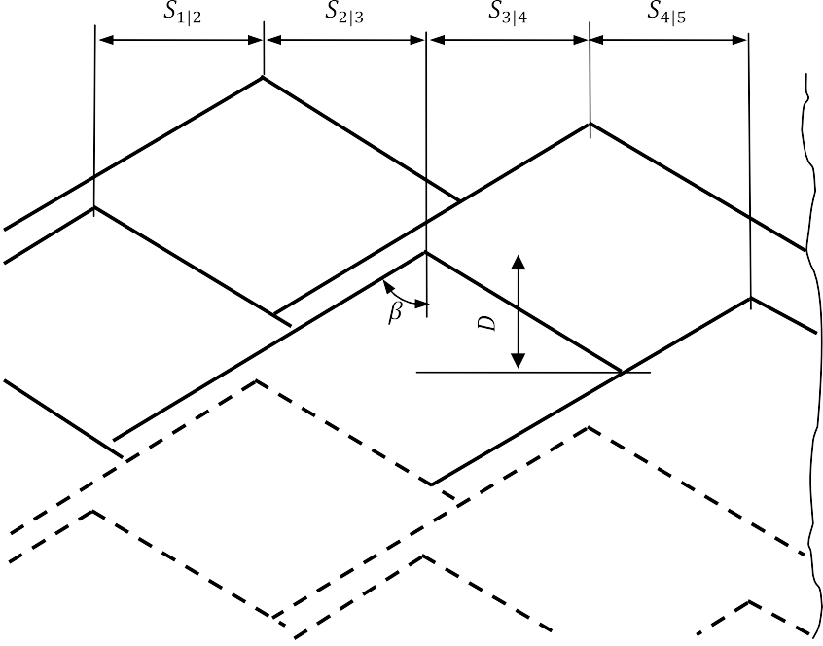

Cut by Pick Cut by Pick Cut by Pick Cut by Pick

1 2 3 4

Cut by Pick 5

Pick locations along drum axial direction (b)

Fig. 1 An example of breakout pattern (a) without cutting interactions and (b) with cutting interactions

When the advance speed of the drum reaches a certain level, the cuts between picks will interact with each other. Fig. 1 shows an example that the cut of Pick 3 has been affected by other picks. It can be found that the chip breakout lines of Pick 2, 4 and 5 have crossed the cutting path of Pick 3 and removed some rock material before Pick 3 cut the rock again. In fact, not only is the cut of Pick 3 affected by the cuts of other picks, it also affects the cut of other picks, i.e., the cuts of Picks 1 and 2 in this example.

The cutting interactions have reduced the “actual” DOC of picks. Take Pick 3 as an example, when there is not cutting interactions, its DOC is equal to its advance displacement in a revolution, i.e.,

 . *(2)*

When cutting interactions happen, its “actual” DOC will become smaller than . It is a function of the line spacing between Pick 3 and other picks, the angular positions of Pick 3 over other picks, the breakout angle and the advance displacement in a revolution of the drum. Refer to [11] for more details. In the following section, the influence of the cutting interactions on cutting force of a pick is investigated.

# Changes of pick cutting force due to cutting interactions

Various numerical simulations have been conducted to investigate the influences of the cutting interactions on cutting force of a pick. In these simulations, the following cutting force models are considered:

 *16 2*cos*2 * . *(3)*



*2*

Eq. (3) is presented by Evans [3] for point-attack picks. In this equation,  is (peak) cutting force,  and  are the tensile strength and uniaxial compressive strength of the rock being cut respectively,  is the semi- conical angle of a pick.

*(4)*

Eq. (4) is presented by Liu, et al [7] for point-attack picks. In this equation,  is mean cutting force.

*(5)*



Eq. (5) is presented by Yilmaz, et al [6] for radial picks. In this equation, is peak cutting force,  is the shear strength of the rock being cut,  is the sliding frictional angle between cutting bit and the rock,  is bit width, and  is rake angle.

Table 1 shows the major parameters that were used in the simulations.

Table 1. Parameters assumed in the simulations

|  |  |  |  |  |  |  |  |  |
| --- | --- | --- | --- | --- | --- | --- | --- | --- |
| Chip  Parameters breakout angle | Drum  rotational speed | Drum starts | Line spacing | Line spacing | Line spacing | Line spacing | Angular  position of Pick 3 over | Angular  position of Pick 2 over |
| (deg.) | (rpm) |  | (mm) | (mm) | (mm) | (mm) | Pick 4 (deg,) | Pick 5 (deg.) |
| Value 60 | 49 | 2 | 78 | 78 | 78 | 78 | 150 | -56 |

Three example results are presented in Figs 2 - 4. To obtain Fig. 2, it was further assumed that the tensile strength and the uniaxial compressive strength of the rock were 6 MPa and 55 MPa respectively, and the semi- conical angle of the pick was 40 degree. To obtain Fig. 4, it was assumed that the uniaxial compressive strength and shear strength of the rock were 120 MPa and 40 MPa respectively, the sliding frictional angle was 30 degree, the bit width was 20 mm, and the rake angle was -5 degree.

From Figs. 2 – 4, it can be seen that the predicted cutting forces without considering cutting interactions are all overestimated. Especially when the drum runs at a high linear advance speed, the predicted cutting forces without considering cutting interactions are significantly higher than the estimated cutting forces with a consideration of cutting interactions.

An additional interesting finding from the simulation is that the cutting forces calculated using Eq. (4) dramatically increased with the linear advance speed of the drum (Fig. 3). Considering Eq. (4) was developed according to laboratory cutting tests on coals with DOC less than 5.5 mm, its applicability to large DOC should be investigated carefully.

800000

700000

Without cutting

interactions

600000

500000

With cutting

interactions

400000

300000

200000

100000

0

0

1

2

3

4

5

6

**Drum linear advance speed (m/min)**

**Cutting force (kN)**

Fig. 2. Cutting force predicted by Eq. (3)

Without cutting interactions

With cutting interactions

**Cutting force (kN)**

50000000

45000000

40000000

35000000

30000000

25000000

20000000

15000000

10000000

5000000

0

0

1

2

3

4

5

6

**Drum linear advance speed (m/min)**

Fig. 3. Cutting force predicted by Eq. (4)

250

200

150

100

50

0

0

1

2

3

4

5

6

**Drum linear advance speed (m/min)**

Fig. 4. Cutting force predicted by Eq. (5)

Without cutting interactions

With cutting interactions

**Cutting force (kN)**

# Conclusions

In rock cutting, picks could have cutting interactions with each other when the linear advance speed reaches a certain level. The cutting interactions could reduce the “actual” cutting forces on picks.

Existing cutting force models are normally developed based on small DOC used in laboratory experiments without significant cutting interactions. Care should be taken when these models are applied to the actual applications with large DOC.

# References

1. Sun Y, Li X, Modeling the property variation of diamond composite and its impact on the reliability of cutting tools. Adv Materials Res 2012;565:448-53.
2. Asburay B, Cigia M. Design methodology testing and evaluation of a continuous miner cutterhead for dust reduction in underground coal mining. *SME Annual Meeting*, Phoenix, USA, 2002: preprint 02-136.
3. Evans I. A theory of the cutting force for point-attack picks, Int J Mining Eng 1984;2:63-71.
4. Goktan RM. A suggested improvement on Evans’ cutting theory for conical bits. *The fourth international symposium on mine mechanization and automation*, edited by Gurgenci H, & Hood M, Brisbane, Australia, 1997:57-61.
5. Goktan RM, Gunnes N. A semi-empirical approach to cutting force prediction for point-attack picks. J South African Ins Mining Met 2005;105:257-63.
6. Yilmaz NG, Yurdakul RM, Goktan RM. Prediction of radial bit cutting force in high-strength rocks using multiple linear regression analysis. Int J Rock Mech Ming Sci 2007;44:962-70.
7. Liu SY, Du CL, Cui XX. Research on the cutting force of a pick. Mining Sci Tech 2009;19:514-17.
8. Su O, Akcin NA. Numerical simulation of rock cutting using the discrete element method. Int J Rock Mech Ming Sci 2011;48:434-42.
9. Hurt K, Morris CJ. The design and operation of boom tunnelling machine cutting heads. *14th Canadian Rock Mechanics Symposium on "Rock Breaking and Mechanical Excavation"*, Vancouver, British Columbia, 1982: 54-58.
10. Liu ZC, Roxborough F. The depth of cut produced by a shearer drum. Mining Sci Tech 1996: 583-8.
11. Sun Y, Li X, Shao W. Influence of cutting parameters and interactions on the depth of cut in continuous mining operation. Adv Materials Res 2012;538-41:1422-8.